State of the Parish
2020
Printed January 28, 2021

Employees: In January, the parish hired a new Business Manager, Dave Papajcik. In February, Deacon Ed Chernick retired from the Business Manager position and continues as the parish deacon. In July, the parish hired John Franks as the new parish Director of Music. In August, Wally Bednarz retired from the parish position as the Director of Music. In January, Bishop Perez was appointed Archbishop of Philadelphia. In September, Bishop Malesic became the new Bishop of Cleveland.

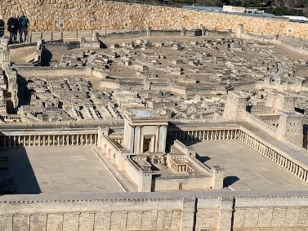
Pilgrimage: In February, Fr. Michael Stalla and many of our parishioners went on a pilgrimage to the Holy Land. Several of the parish catechists were given a reduced rate for the pilgrimage thanks to the Fr. Friedel Bequest. It was authentically a pilgrimage, and not a vacation. We prayerfully approached each day, each difficulty, and each holy location as if we were on retreat, preparing us to return with a new appreciation, enthusiasm, and spiritual fortitude to offer our witness to the children, teens, and fellow parishioners of Twinsburg.

Parish Mission: During Lent, we were able to have our Parish Mission, directed by Michael Reardon. It was a masterful enactment of the Gospel of Mark, which was the cycle of readings the Church used throughout this last year. There was a sense of the continuity of each of the readings.

Pandemic: In March, the Coronavirus pandemic seriously interrupted parish life. We implemented new safety procedures: Masks, Social Distancing, Seating Arrangements, No singing, paying the church pews, classrooms, and Adoration Chapel.

Technology: As a parish, we updated our parish computers and server. We contracted with a new technology company. We developed a parish website and parish Facebook page. We installed cameras in the church and in the classroom. We scheduled online adoration, rosary, Divine Mercy, Morning Prayer, Evening Prayer, Night Prayer, Holy Mass, Bible Study, Church teachings, and, when requested, graveside services and funerals.

Attendance: For many weeks, the Holy Mass had no attendance, including for Holy Week. As the State restrictions were lifted, we have only had about 50% of our typical weekend attendance, though the daily Mass has returned to its usual size. The online attendance spiked in April with over 2000 views, but has since dwindled to around 600.

Faith Formation: Due to the restrictions with gathering the students, we changed the model of our Faith Formation to an online program our parish developed, called First Disciple. It is an absolutely excellent program that the diocese have given us permission to pilot. It focuses on personal spirituality. Our aim was to use this time as a type of retreat that solidifies a Catholic identity that will serve the young for years to come. Confirmation and First Communion were delayed five months. Those who intended to enter into the Catholic Church at the Easter Vigil received their Sacraments of Initiation at Pentecost.

Ministries: Other ministries and parish events responded creatively to the Coronavirus Pandemic.
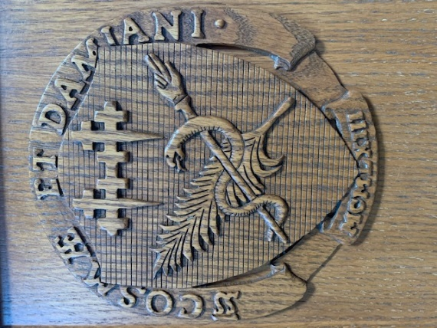
- The Parish Retreat is postponed, but ready to spring into action;
- The Pre Cana Retreat team graciously offered Couple-to-Couple ministry as an alternative;
- The confirmandi joined Fr. Michael for a virtual lunch, we are redesigning the Catholic Heart Work Camp to be a local event this summer;
- The Parish Fish Fry had about two weeks before we decided to let support the local businesses;
- For the Night Under the Stars we opted have an outdoor Mass for the parish feast day;
- Since we cannot have Nursing Home Masses, we have been in close communication with the any needs they have for those in Hospice;
- We began a ministry to reach out to the homebound through phone calls and care packages. There are substantially more numerous as there are many vulnerable parishioners who appreciate the online Masses over the risk of gathering in crowds;
- Confessions are held individually in the Adoration Chapel so as to keep proper social distancing and supplement our Lenten Communal Penance Service;
- The Alpha High School Program followed the school policy of presence;
- The Poustinia Retreat skipped a year, but plan to regroup;
- In lieu of the Baccalaureate Prayer Service, we had big letters in the front of the parish grounds congratulating our graduates;
- The Ignite Mass music was moved to the 11:00 AM Sunday Mass;
- The After Mass Prayer Ministry provided a Prayer Request box in the church;
- Greeters became sprayers to keep the church clean;
- The Children’s Liturgy of the Word became a Children’s Journey classes on Wednesday night for those who need baptism;
- Bereavement ministry focused on ways we can use our church for wake services;
- Eucharistic Ministers to the Homebound became a prayer chain by calling frequently those that are feeling isolate;
- The Youth Group and Y-Disciples focused on the new and improved First Disciple catechetical program, utilizing videos and personal encounters with Christ;
- The servers became bell-ringers; and
- The lectors and choir are eager to return to ministry.

Some of our parish groups struggle to meet, even minimally, including the Women’s Group, Holy Name Society, 55 Plus, Morning Rosary. Yet, despite the difficulty, they continue to focus on a triumphant awakening from hibernation when the day comes.

New and Ongoing Ministries: Some new ministries were created.
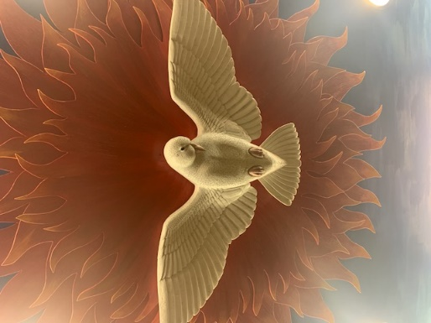
- Missionary Childhood: Fun program where teenagers teach younger students about Catholics around the world and their cultural expression of the Faith.
- First Disciple: Type of Faith Formation program designed to emphasize a personal encounter with Christ through an online teaching pedagogy. Mary, the First Disciple, is our model.
- Oasis: Working with the surrounding Catholic parishes in ministries that naturally overlap.
- Eternally Loved Retreat: An eight-week retreat designed to introduce Christ as the Bridegroom. It is a biblical image of God’s spousal love for humanity that aims to heal our broken misconceptions about relationships, family, and love.
- Children Disciples: For children between 7 and 14 years old who desire to be baptized Catholic.
- Tea Bible Study: A morning Bible Study with Joni Smith.
- Weekly Faith Formation News Updates: A recording sent to the First Disciple Students and their parents to keep parishioners involved, motivated and informed.
- Theology of the Body. Beginning with a conference at St. Barnabas, by Christopher West, the parish continues a series of workshops designed to unpack the beautiful teachings of St. John Paul II regarding Love and Family.
- Greet-A-Family: Established parishioners are introduced to new parishioners as a welcoming gesture to know a similar family in the parish.
- Pre-Mass Musicians: Musicians sing and play instruments prior to the Mass.

Some ministries continue, though in a new way. Disciple’s Formation (Adult Formation). Journey of Faith (RCIA). Sacristans. Ushers. Adorers. Knights of Columbus. Charismatic Prayer Group. Community of the Risen Lord. Prayer Shawl Ministry. Pro Life Family. Thea Bowman Center. Marthas. Art and Environment. Emergency Assistance. Retired and Active.

Finances:
- Our overall collections have diminished by $5,357 (-1.04%). That is amazing! You are such dedicated, generous parishioners!
- The Federal PPP forgivable loan was able to provide $71,000 in relief for our parish payroll.
- We received extraordinary gifts of $15,767.
- From our Parish Capital Campaign, we received $227,899.16.
- We did not need to lay off any employees.
- The diocese had given us permission to delay our Assessment payments. Due to your continued support, we were in a better position than most parishes. Therefore, we declined their offer.
- We paid $137,000 toward the mortgage this year, leaving us with $469,061 remaining on the mortgage with an interest rate of 5.1%.
- After expenses we were able to raise $8,792.03 from the Grotto, the rosary sales, the raffle tickets for a miniature Our Lady of Grace statue, and from the memorial bricks.
- We began the Heart of a Shepherd Campaign, which has $186,000 pledged over the next 3-5 years (Our goal was $185,000).
- Our Emergency Assistance started out with a beginning balance of $9,681.07 collected $12,662.00 of funds and a significant amount of non-perishable goods. They distributed $9,536.37 of funds and a significant amount of non-perishable goods. Their Year End Balance is $12,687.85.

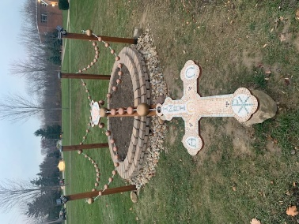
Parish Projects: We were able to complete various projects:

- Walkway in front of the church.
- Parish Grotto.
- Parish Property Lights.
- Parish Parking Lot.
- Sanctuary Renovations.
- Parish Signs.
- Parish Technology.
- Rosary Monument
- Out Door Stations (Via Dolorosa)

Statistics: During this year, we have had:

17 Baptisms
7 Weddings
39 Funerals
49 New Families joined the parish
29 First Communicants
20 Confirmation
5 New Catholics
1 Seminarians
0 Religious Sisters
1 Deacon Candidates

2021: Things to look forward to in the coming year:
- Delayed Confirmation (19) and First Communion (24) until October.
- Renovation of Multi-Purpose Room to become four classrooms and a conference Room (≈$35,000 [From the Fr. Friedel Bequest]).
- Lights in the Church (≈$8,000 [Capital Campaign])
- Renovation of Twinhaven. (≈$10,000 [Fr. Friedel Bequest])
- Twinhaven AC/HVAC (≈$12,500)
- Collaboration with surrounding parishes to have a youth Summer Service program (≈$57,375 [Grant])
- Collaboration with Surround parish to form a Young Adults Ministry
- Kingsman Men’s Renewal
- Feminine Genius Women’s Renewal Group
- 7 Candidates for RCIA- Becoming Catholic at the Easter Vigil
- 8 Weddings planned.

Overall Assessment:
- Youth and Young Families have not been very visible, but we believe they desire community and will be looking for each other in the congregation. It will take effort to make them feel welcome and reestablish faith as a priority.
- Youth Catechetical Program is stellar.
- Collections are stable, thanks to your dedication and commitment.
- Many ministries are in need of rebuilding and technology assistance.
- Online presence is better than ever.
- The diminished Mass attendance is around 50%, but people are coming back. The online presence has greatly increased the number of people we serve.

Report submitted by Fr. Michael Stalla, Pastor.

